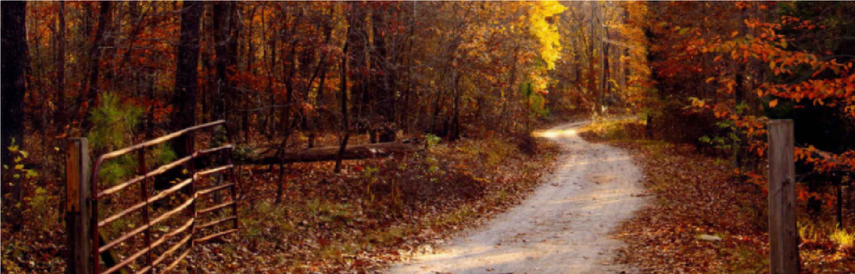
Shakerag Hounds Fall Fun Ride at Inyazura Farms
November 28, 2020

Join us for a beautiful fall day of riding in a socially distant manner on over 600 acres.
Inyazura Farms has opened up its miles of trails for a Shakerag Hounds benefit fun ride!
Inyazura is a unique boarding facility located just north of Athens, Georgia with options for both stall and pasture boarding. In addition to having multiple rings (including a covered arena) and a cross-country course, the farm foxhunts with Shakerag every week. Riding lessons are available as well as lease horses for hunts.
Casual attire is acceptable for the fun ride, but helmets are required for both English and
Western riders. The first riders will set out at 8:30 AM and the last riders will set out at 11 AM. Trails are well marked and jumps are optional. Choose your speed!
Location:
Parking will be at the Inyazura Farms cross-country field:
8146 Jefferson River Road Athens, GA 30607
FEES FOR THE RIDE
$40 for Juniors (18 and Under) and $50 for Adults
Please pay in advance by 5 PM on November 27, 2020 to participate. Online payment through the Shakerag Hounds website https://www.shakeraghounds.com/ is required. (No refunds for no shows.) If you plan to participate, please read and adhere to our Shakerag Hounds rules in connection with COVID-19 available at this link.
Submit in advance a signed Shakerag Release and COVID-19 Release, as well as the Inyazura Farms release, plus a digital file of your current Coggins for each rider and horse. These will serve as your RSVP for the ride, questions and your forms must be emailed in advance to Jenny Lamb at manager@inyazurafarms.com and be sure to cc Shakerag’s Honorary Secretary, Tara Stricko at huntsecretary@shakeraghounds.com.

